**Vector & Bitmap Graphics**

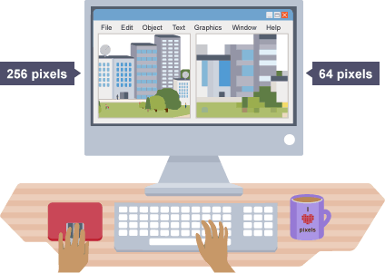**Bit mapped graphics**

A bit mapped graphic is a 2-dimensional array of pixels. The total number of pixels in an image is known as the *resolution*, and the number of colours that can be used is determined by the *bit depth*.

An example of a black and white graphic would be that a white pixel is stored as a 0, and a black pixel is stored as a 1.

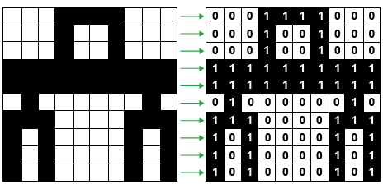

In this graphic, there are are 64 pixels (an 8x8 image). However, if the image included colour, it would be necessary to store more than one bit per pixel. The more bits you allocate for every pixel, the larger the file will be.

*Bit depth* is the term used to describe the number of bits to each pixel in an image.

|  |  |
| --- | --- |
| Bit Depth | Available Colours |
| 8 bits per pixel | 256 (28) |
| 16 bits per pixel | 65536 (216) |
| 24 bits per pixel | 16777216 (224) |

**Vector Graphics**

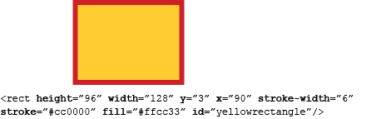Vector graphics are stored as “scalable vector graphic (svg)” files. Instead of being stored as a 2d array of pixels, vectors are stored as a list of attributes. This means vector files will not become blurry as they are scaled up. The computer generates an object by looking at its attributes.

In the example on the right, the *attributes* are shown in **bold**, and their values come immediately after the = sign.

Changing the complexity of the svg file will potentially change the file size, as there are more attributes for the computer to store and process.